Weather wise
AI Weather Wise API – Project Explanation

Team ID | SWTID-2026-9703
Project Name | AI WeatherWise API

TEAM LEADER | RAMYA M
EMAIL ID | sac2427bca5216@ssacollegachennai.com
TEAM MEMBER | RAJASHREE M
EMAIL ID | sac2427bac5379@ssacollegechennai.com
TEAM MEMBER | QUEEN SHEEBA G
EMAIL ID | sac2427bac5304@ssacollegechennai.com
TEAM MEMBER | REKHA P
EMAIL ID | sac2427bca5256@ssacollegechennai.com

AI Weather Wise API – Project Explanation

1. Introduction
AI Weather Wise API is a weather-based application that uses an API (Application Programming Interface) to collect weather information from a weather service and present it to the user in an easy-to-understand format.
The system can provide information such as:
- Temperature
- Weather condition
- Humidity
- Wind speed
- Chance of rain
- Location-based weather

2. What is an API?
An API allows two different software applications to communicate with each other.
For example:
User → Weather Wise Application → Weather API → Weather Data → User
When the user enters a city name, the application sends a request to the weather API. The API returns the current weather data, which is then displayed on the screen.

3. Why AI is used?
The AI part can make the application more useful by analyzing the weather information and giving simple recommendations.
For example:
Weather: 32°C, partly cloudy
AI Suggestion: “The weather is warm. Carry a water bottle and consider using an umbrella if you are sensitive to sunlight.”
AI can also convert technical weather data into simple natural-language advice.

4. Main Features
1. City Search
The user enters a city or location.
2. Weather Data Retrieval
he application sends the location to the weather API.
3. Weather Display
The application displays temperature, humidity, wind speed, and weather conditions.
4. AI-Based Advice
The system analyzes the weather information and provides useful suggestions.
5. User-Friendly Interface
The weather information is displayed clearly using cards, icons, and simple text.

5. Working Process

User enters city
↓
Application sends API request
↓
Weather API provides data
↓
Application processes the data
↓
AI analyzes the weather
↓
Suggestion is generated
↓
Weather + AI advice displayed to user

6. Technologies Used
Depending on your actual implementation, you can mention:
- HTML – Creates the webpage structure
- CSS – Designs the user interface
- JavaScript – Handles user interaction and API requests
- Weather API – Provides real-time weather data
- AI/ML or AI service – Generates weather-based recommendations
- JSON – Used to receive and process API data

7. Advantages
- Provides weather information quickly.
- Easy for users to understand.
- Gives location-based weather information.
- AI can provide personalized weather suggestions.
- Reduces the need to manually interpret weather data.
- Can be extended with forecasts and alerts.

8. Future Enhancements
In the future, the project can include:
- 7-day weather forecasts
- Severe weather alerts
- Voice-based weather search
- Multiple-language support
- Travel recommendations based on weather
- Personalized clothing/activity suggestions

9. Conclusion
AI Weather Wise API combines weather API technology with AI to provide weather information along with simple and useful recommendations. The main goal of the project is to make weather information easy to access, understand, and use in daily life.

SCREEEN SHOT:
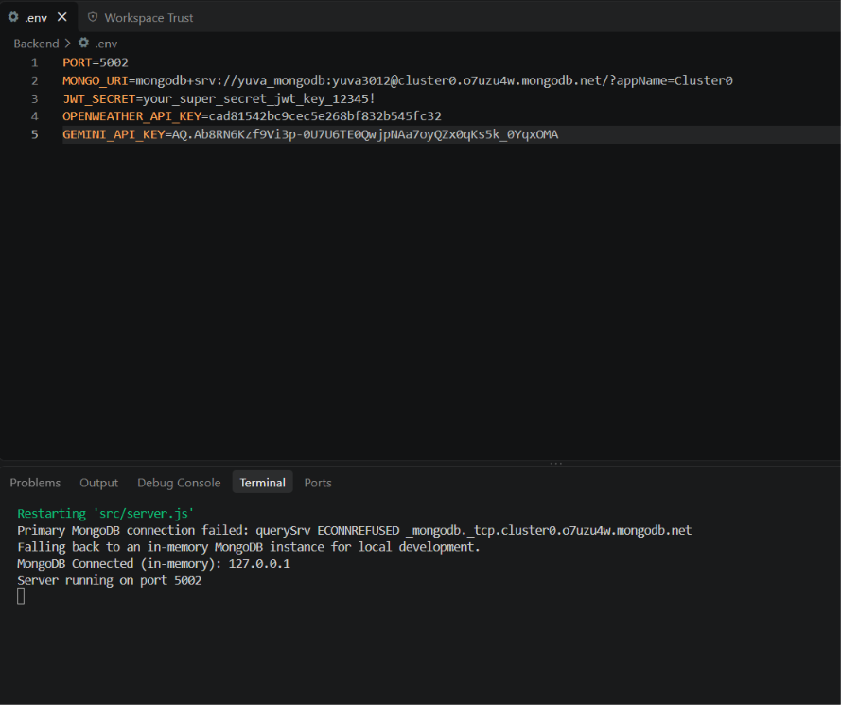

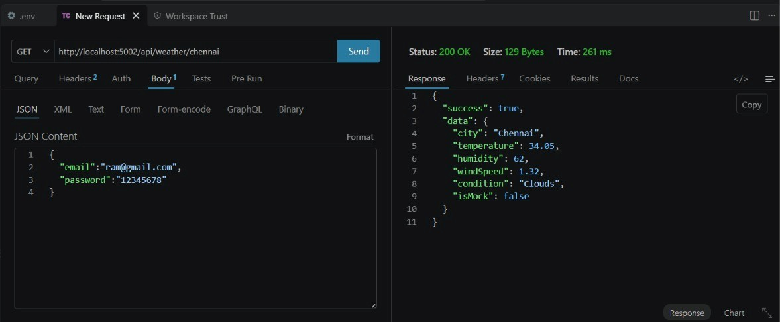

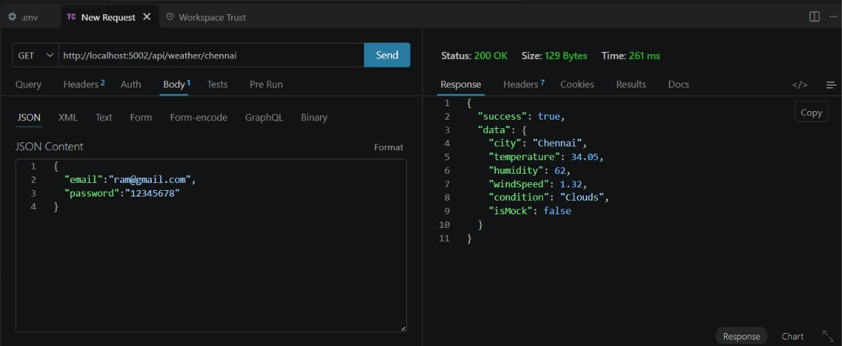

API TESTING VIDEO LINK: api video.mp4

DEMO VIDEO: backend demo.mp4

CODE DRIVE: code

